QUICK & EASY STRESS TIPS
Drink lots of water – keep your body hydrated so you can think clearly
Eat regularly – maintain your energy levels
Reduce junk foods – sugars and fats can make you sluggish
Exercise when you can – bike rides, swimming, dancing, walking
Avoid excess caffeine intake – (energy drinks and coffee) which can increase feelings of anxiety and agitation
Relax in a hot bath
Practice deep breathing – to increase the oxygen to your brain which helps you stay calm
Make time for yourself to switch off – read, listen to music, watch a film
Get plenty of sleep
Plan each day – structure provides a sense of security
Look forward to a night out or a holiday
Smile - release endorphins, the feel-good hormones
Have fun with friends and laugh
Keep a journal of your thoughts and feelings –better out than in!

These may take a little longer to implement but are worth noting.

BALANCE & CONTROL TIPS
Work out, WHAT and WHO causes you stress, WHEN and possibly WHY then you can work on HOW to manage it.
Avoid any unnecessary conflict
Have an attitude of gratitude (be thankful for what you have)
Talk to someone you trust
Be proud when you do something well
Don’t be too hard on yourself when you make a mistake
Take a break from stressful situations
Pace yourself
Build a network of trusted friends for mutual support
Try and plan so you feel in control
Don’t over commit yourself
Be assertive (see Helpful Stuff)
Rehearse and practice situations that cause you stress (presentations, interviews)
Don’t over commit or make promises you can’t keep Try to reduce excessive drinking, drugs and smoking

BURNOUT
Burnout is the result of mental, physical, and emotional exhaustion due to ongoing demands, pressures, and expectations. It is generally considered to be work related, but others can suffer too. Good examples are carers or family members looking after someone with a severe disability or dementia with no support.
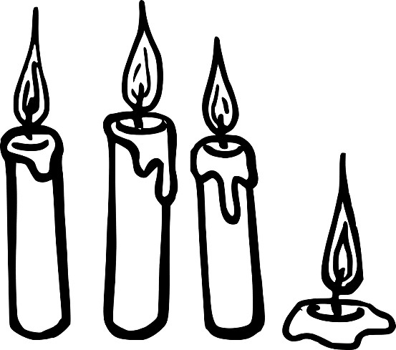
Burnout is defined by the World Health Organization as an official syndrome related to “chronic workplace stress that has not been successfully managed.”

CAUSES OF BURNOUT
In a nutshell – priorities, processes, personalities, pessimism, perfectionism, and pressures all contribute to burnout.
- Priorities – which are not your own can cause stress especially if they are not in line with your value system
- Pressures – high expectations to meet deadlines which can impact on others plus unmanageable workloads
- Personalities – personality A is more likely to suffer from burnout than personality B. Personality clashes and dominant personalities in management do not help!
- Professionalism (lack of) from colleagues and management. Limited guidance and support.
- Processes – lack of clarity on roles and responsibilities
- Perfectionism – feeling inadequate can be a driver to do more and more to prove that you are good enough
(or better)
- Productivity – poor time management prevents completion of tasks.
- Pessimism - a negative workforce and culture
- Planning – not having a work plan or personal development plan can contribute to burnout.
- Performance – no work life balance (Poor planning prevents performance)
Noncompliance with HSE Management Standards WHAT TO LOOK FOR:

BURNOUT PREVENTION TIPS
Plan each day carefully and try to stick to it
Keep an eye on your time management
Work your contracted hours as far as possible
Write a “To do list” every day and prioritise tasks
Set clear boundaries
Learn to say no without feeling guilty
Keep your manager up to speed if you are not coping
Share personal things that may be holding you back
Ask for training if needed
Take regular breaks from your computer
Have a lunch break every day and get some fresh air
Learn EFT to release stress as it arises
Plan holidays and days out to look forward to.
Don’t take work home
Avoid work calls and emails out of working hours

EMDR
EMDR stands for Eye Movement Desensitisation Reprocessing and it has been around since. 1989 when it was discovered and developed by Francine Shapiro.
Doing this yourself is easy Wherever you are, there will be a door, window, bookcase or Tv screen (approx. 1 metre wide. It will only take a couple of minutes

- Measure the intensity of the emotion from 1-10 or visualise the memory or situation that is causing stress.
- Follow a line there and back x 24 with your eyes, keeping your head still.
- Take a deep breath in and out
- Measure the intensity once more

If it has dropped so that it doesn’t bother you any more then stop. If something else comes to mind….Repeat OR Change Direction
- 24 eye movements again (diagonally)
- Deep breath
- Measure once more
24 again on the opposite diagonal
Your eyes will become tired and you can feel your body slowing down. Usually horizontal eye movements are sufficient to make an emotional shift.
It is a good way of getting off to sleep as the eyes tire quite quickly.

